Winter is Coming!
Glacier National Park
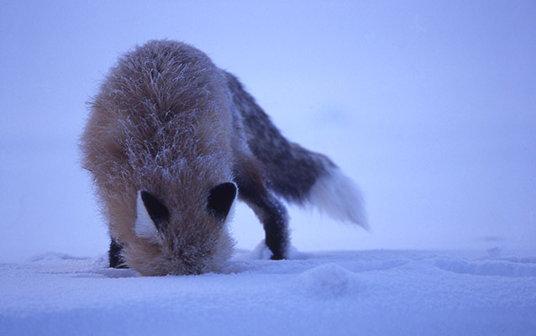
Red fox in winter. NPS Photo

GRADE LEVEL:
Third Grade-Fifth Grade
GROUP SIZE:
Up to 24
SETTING:
classroom
NATIONAL/STATE STANDARDS:
MT.SCI.K-12.3.4 Students, through the inquiry process, demonstrate knowledge of characteristics, structures and function of living things, the process and diversity of life, and how living organisms interact with each other and their environment.
KEYWORDS:
hibernation, migration, resist, winter

Overview
Students will play a running game that emphasizes the three main ways that animals adapt to the winter (hibernate, migrate, and resist). They will also learn different terms related to winter in Glacier.

Objective(s)
- List 3 animal adaptations for surviving winter (hibernate, migrate, resistance)
- List survival strategies animals may use in the winter (yarding, camouflage, etc.)
- Explain the word "subnivean" and why it is important in the winter

Background
In order to survive, animals can choose to migrate (go somewhere else), hibernate (sleep through the winter), or just resist (and put up with the winter). For those that resist, there are many strategies that they use to survive. Some animals use camouflage to blend in with the snow (for instance, snowshoe hares). Deer often yard, or gather in an area that they have stomped down. Smaller animals will sometimes huddle together to stay warm. For many animals, the subnivean (or under the snow) is necessary to survival. Animals like mice and voles will often make tunnels under the snow, using the insulation of snow to stay protected. This game emphasizes some of those strategies and the three ways that animals can survive the winter. Get more information on animal survival in winter!

Materials
Hibernate, Migrate, Resist Signs
Optional: large pictures of Glacier National Park animals

Procedure
- Gather students together in a big open area to play the game. Explain that there are three main ways that animals can survive the winter (hibernate, migrate, resist). After explaining what the three terms mean, pick a base for each survival method (Form a triangle with the bases). Tell the students that when you shout one of those terms, they should run to the designated base. Teacher yells, "Migrate!" students run to the migrate base, "Resist!" students run to the resist base, have then run to each base a few times so they remember where they are.
- Introduce that when they hear "Winter is Coming!" they need to freeze no matter where they are. (more or less freeze tag rules) If they don't freeze, they are temporarily out of the game (icicles), and should go to the middle of the playing area. Students may not move until they hear "Spring Thaw!" At that point, students may move (students that were out, may move as soon as someone still in the game tags them). Practice adding "winter's coming" and "spring thaw" into the game. Teacher yells, "Migrate!" student run to the migrate base, "Resist!" student begin running… "Winter is Coming!" students freeze, those that still run are sent to the middle and become 'icicles.' "Spring Thaw! Hibernate!" students run to the hibernate base and on the way they tag the 'icicles' to unfreeze them, if they decide to. (At this point they understand the basics and you can start mixing it up a bit.)
- Once students get the idea of running to the different bases and "winter's coming," start adding other elements. At this point, they will work either by themselves or with others (depending on how you set it up) to act out different words. Depending on the age and their familiarity with the terms, you may want to introduce just a few terms, play a little more, and then introduce the rest of the terms. Here are some recommended actions: Predator - An animal or other organism (such as a carnivorous plant) that hunts and kills other organisms for food. Each student gets down on all fours and pretends to be a predator. Camouflage -To conceal by the use of disguise or by protective coloring or garments that blend in with the surrounding environment. Two students work together to act out a snowshoe hare (one student stands behind their kneeling partner and give them bunny ears). Subnivean - Under the snow. Three students work together to act out the idea of the subnivean (two students should form a bridge with their arms and the third student should hunch down underneath their arms). Huddling - To crowd together, as from cold or fear. Four or five students huddle together. Yarding - Stay in one location. Four or five students pretend to be deer and stomp down a small area all together.
- Once they know all of the actions, the three main adaptations (bases), and the idea of "Winter's Coming" and "Spring Thaw," you can yell out the actions and bases in any order (and as quickly) as you choose. Because it is a running game, play usually continues until the students become tired.
- Once the game is finished, recap the importance of the different actions and adaptations and why animals choose to do what they do.

Assessment
- Students can correctly name the three adaptations for winter survival
- Students can explain the importance of the subnivean, yarding, huddling, and any other terms that were used in the game.

Extensions
Play the game as described above. Instead of saying the word hibernate, migrate, or resist; show a picture of a Glacier Park animal. Have students run to the base with the correct adaptation for how that animal survives winter.
- It helps to have students think about what each animal eats. For example, most predators (mountain lions, wolves, lynx, etc.) resist because they can continue hunting and getting enough food to stay active and survive in the winter. Animals that hibernate (bears, ground squirrels, frogs, etc.) can't find enough vegetation, insects, or other food necessary to stay active through the winter so they slow down their metabolisms and go to sleep. See the chart on the following page.

